Digital arts

J2S1P1 Chinese courtyard

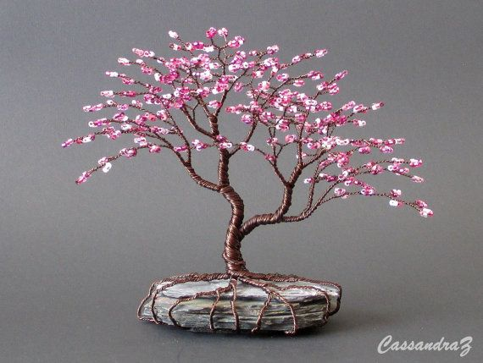

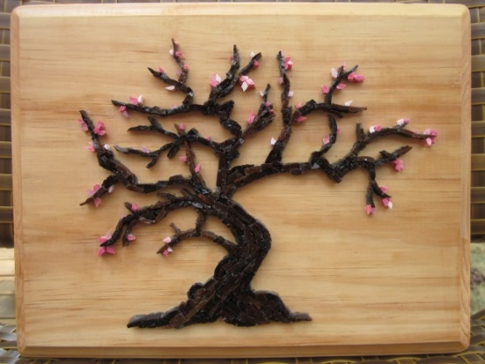

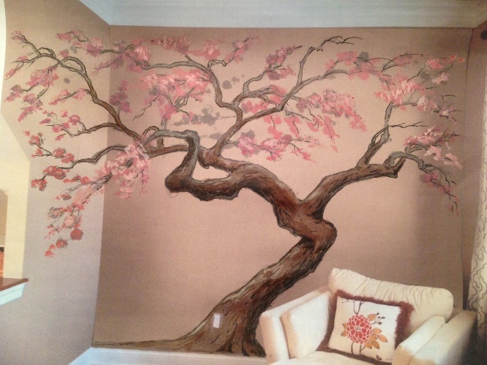

# Gerelateerde afbeeldingStyle guide

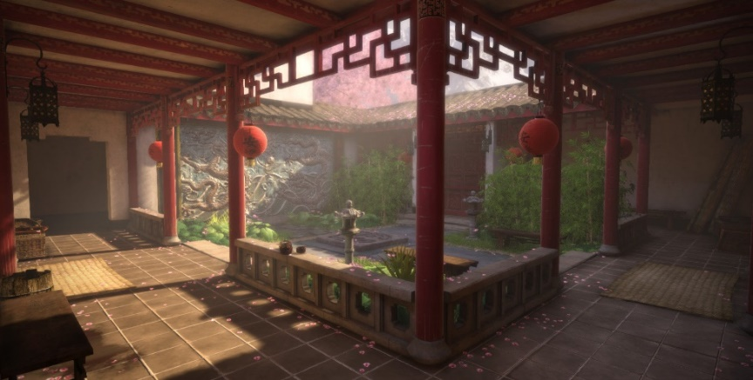

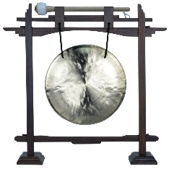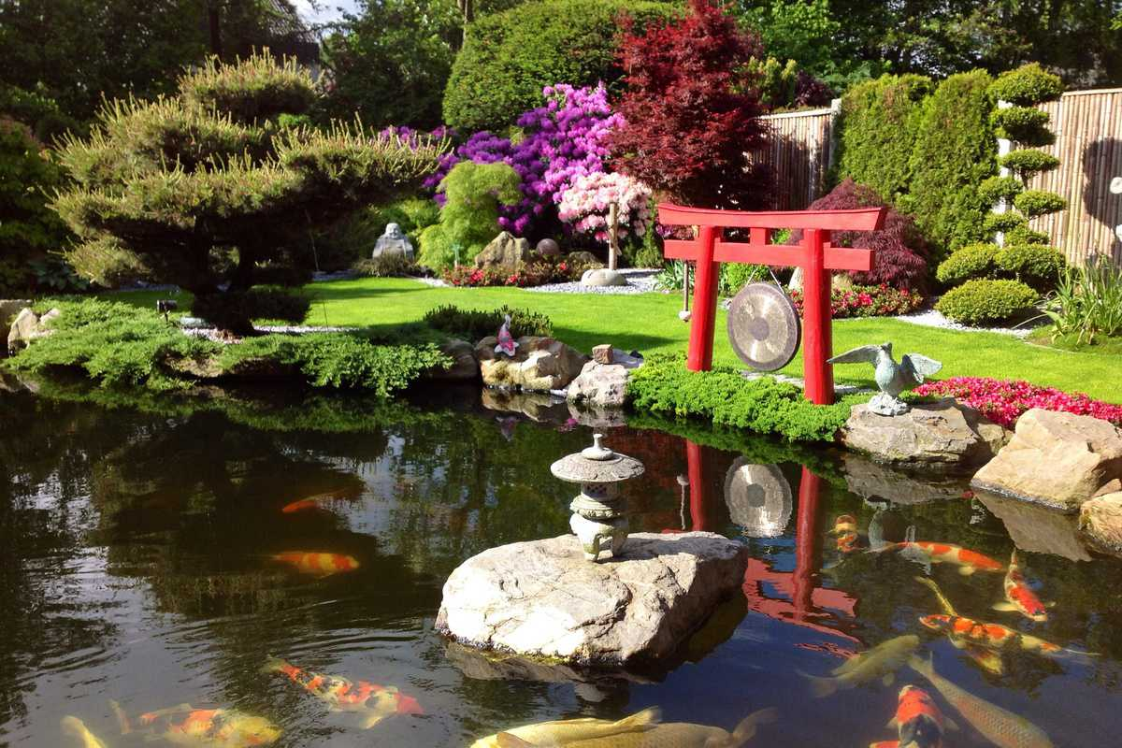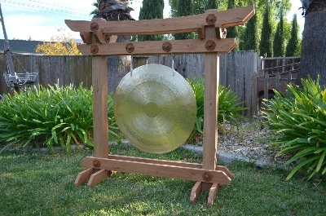

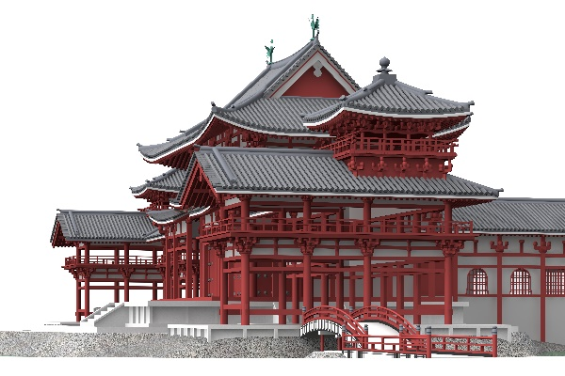

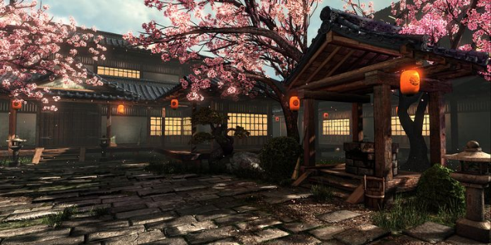Wit, rood, goud, zwart

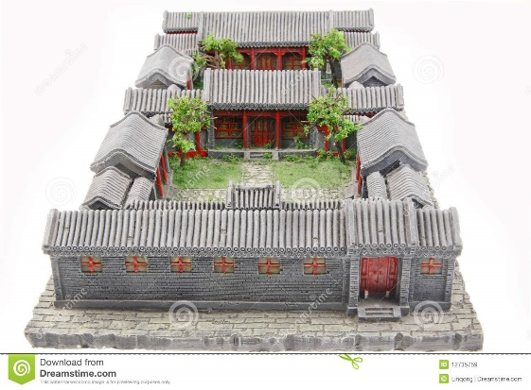

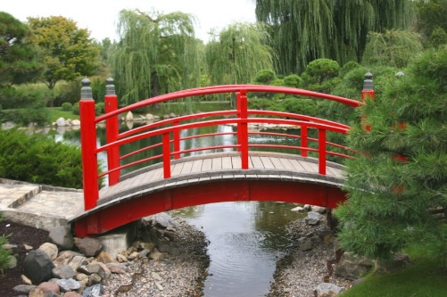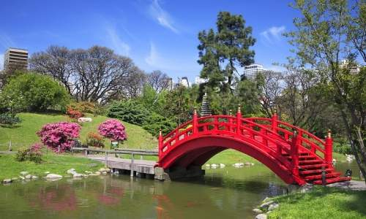

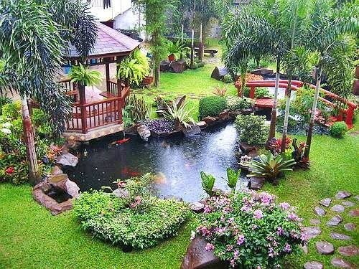

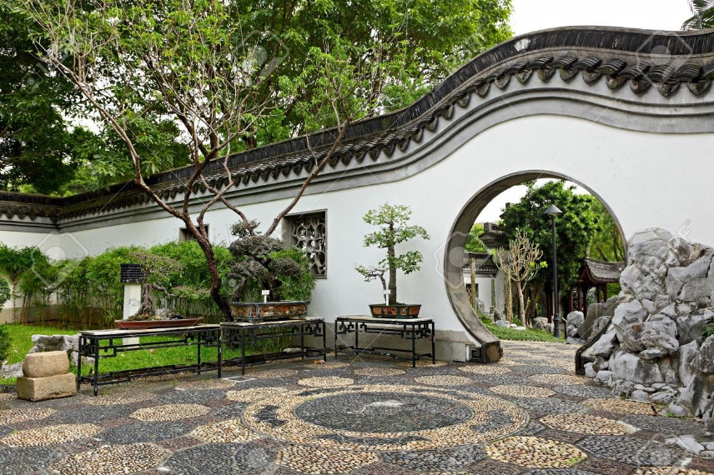

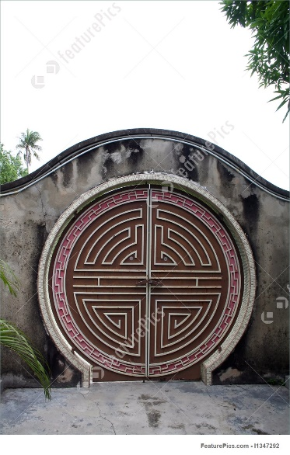

# Models

|  |  |  |  |
| --- | --- | --- | --- |
| Te doen | mee bezig | af | geïmplementeerd |
| *brug* |  | - |  |
| *gong* |  | - |  |
| *zijmuur* |  | - |  |
| *zijmuur deur* |  | - |  |
| *Tempel* |  | - |  |
| *lampion* |  | - |  |
| *karper* | - |  |  |
| *skybox* |  | - |  |
| *Staande lamp* |  | - |  |
| *plant/boom* | - |  |  |

# Unwrap

|  |  |  |  |
| --- | --- | --- | --- |
| Te doen | mee bezig | af | geïmplementeerd |
| *brug* |  |  |  |
| *gong* |  |  |  |
| *zijmuur* |  |  |  |
| *zijmuur deur* |  |  |  |
| *ingangsmuur* |  |  |  |
| *lampion* |  |  |  |
| *karper* |  |  |  |
| *skybox* |  | - |  |
| *Staande lamp* |  | - |  |
| *plant/boom* |  |  |  |

# Textures

|  |  |  |  |
| --- | --- | --- | --- |
| Te doen | mee bezig | af | geïmplementeerd |
| *brug* |  |  |  |
| *gong* |  |  |  |
| *zijmuur* |  |  |  |
| *zijmuur deur* |  |  |  |
| *ingangsmuur* |  |  |  |
| *lampion* |  |  |  |
| *karper* |  |  |  |
| *skybox* | - |  |  |
| *Staande lamp* |  | - |  |
| *plant/boom* |  |  |  |

# Referenties

## Boom

<https://www.youtube.com/watch?v=HXf6D3Gl50E>

<https://www.youtube.com/watch?v=0RwdPIG8SQk>

<https://www.youtube.com/watch?v=HdZ6kN83g-0>

<https://www.google.nl/search?rlz=1C1MSNA_enNL711NL711&biw=2133&bih=1082&tbm=isch&sa=1&q=leaf+texture+atlas&oq=leaf+texture+atlas&gs_l=psy-ab.3...6731.8279.0.8634.5.5.0.0.0.0.54.196.5.5.0....0...1.1.64.psy-ab..0.2.92...0i13k1j0i13i30k1j0i13i5i30k1.xzeLLdBosCQ#imgrc=_>

## Gebouw

<https://www.youtube.com/watch?v=u3D_BE0hkAw>

<https://www.youtube.com/watch?v=eYy6sKMOh2Q>

## Skybox

<https://www.youtube.com/watch?v=PILoMaschCs>

<https://www.youtube.com/watch?v=-ZutidNYVRE>